**Changes To Search Fields For Claims Registration, Claims Payment and Claims Recovery**

1. To Include Vehicle No. as a Search Field
2. Change Date Of Loss To Accident Date
3. Remove Main Class Code and Sub Class Code Search Fields

**Changes To New and Incomplete Claims Registration**

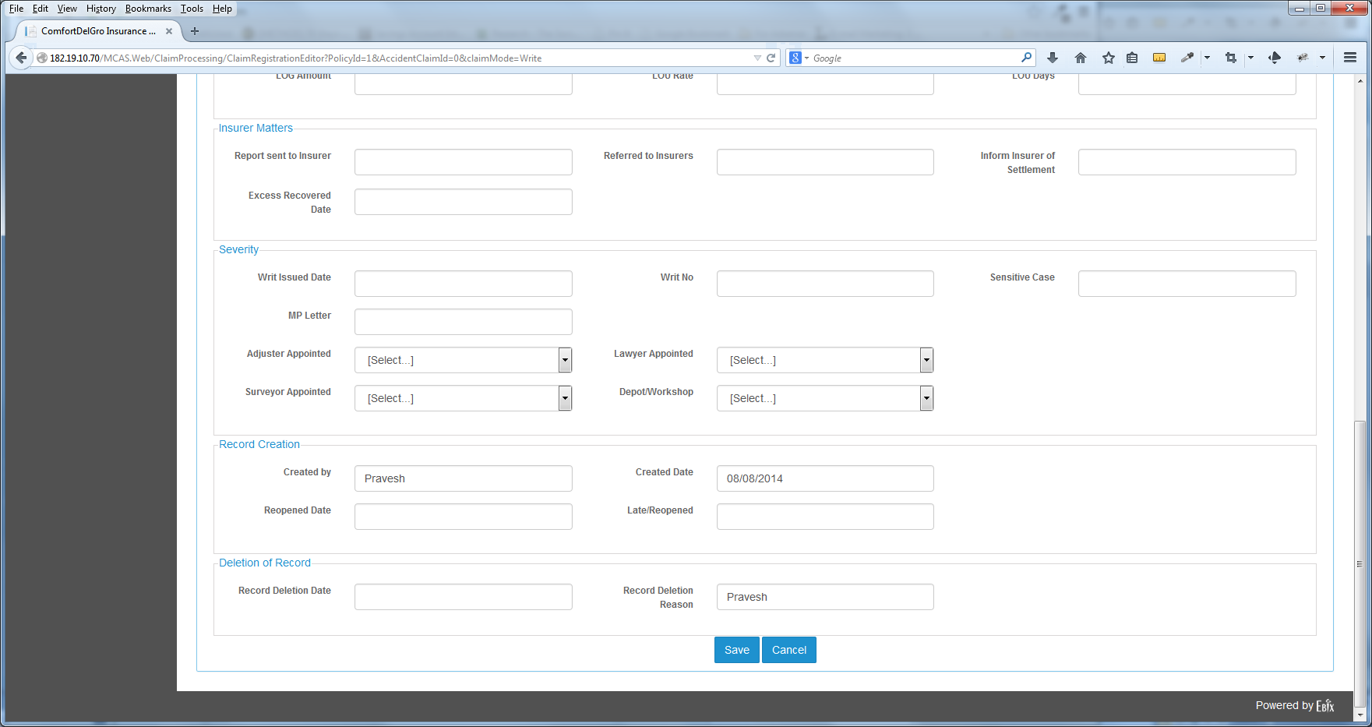

Next

Previous

1. To Include Next and Previous Button in all the Tabs for New Claims Registrations and Incomplete Claims Registration Screen
2. System must save all inputs when user clicks on the Next and Previous Buttons
3. To Change Cancel Label to Reset

**Changes To Claims Tab**

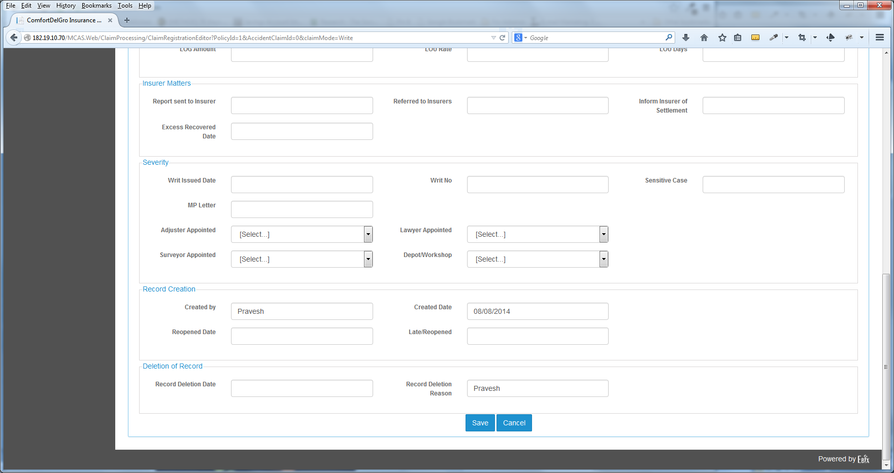

1. To Include Time Stamp on Created Date
2. To Rename Deletion Of Record To Cancellation Of Record
3. To Rename Record Deletion Date to Record Cancellation Date
4. To Rename Record Deletion Reason to Record Cancellation Reason
5. To Extend Wider for the Record Cancellation Reason’s Text Field (100 Characters)
6. System is to take note that when User inputs a date on Record Deletion Date, User must also enter a Deletion Reason. When there are inputs and user clicks on save – System will prompt user with a Message “Are You Sure You Want To Cancel This Claim?” and have options to choose Yes or Cancel. If User clicks Yes, the System will cancel this Claim and update the Claim Status as Cancelled
7. To Remove the Claim Amount/Payout Section
8. To move the View Payment & Reserve History Button to Claims Adjustment & Claims Enquiry Screen
9. To Default the Claim Status to “C”
10. Initial Reserve created in this Tab must be recorded in the Reserve Tab
11. Depot Workshop to be mapped to the Depot Master

**Changes To The Third Party Tab**

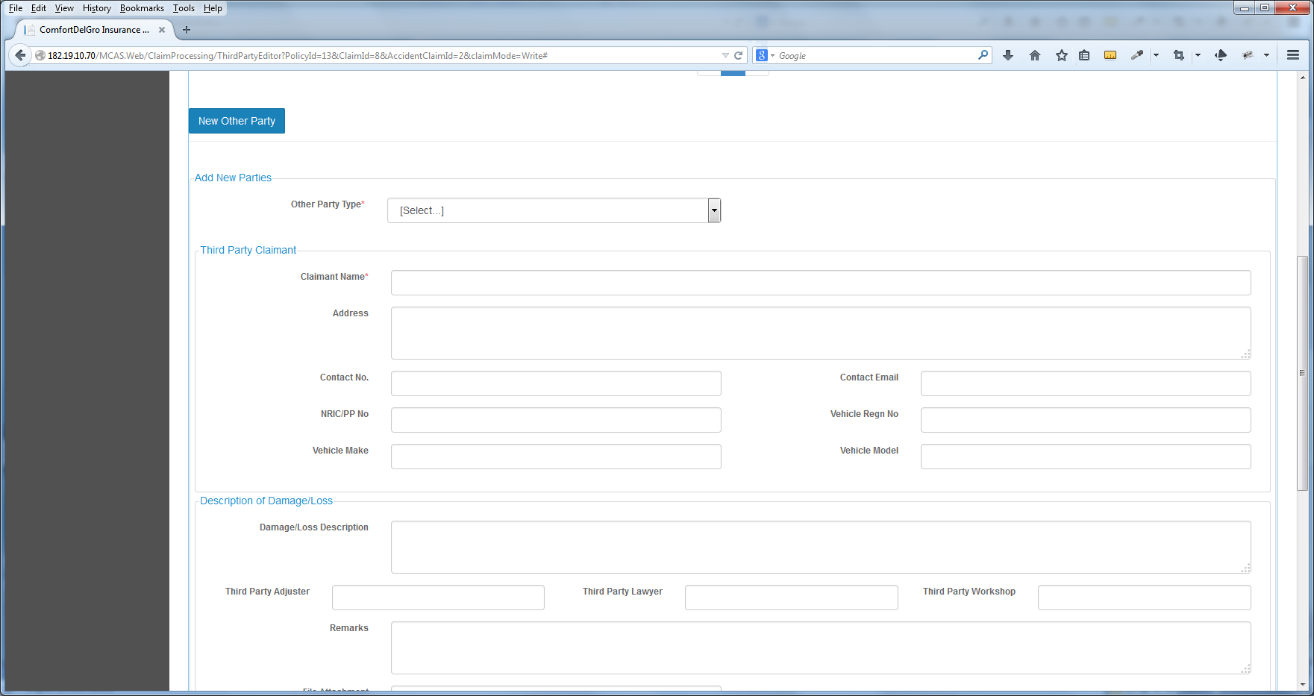

1. To Include Three New Dropdown Listings – Service Provider / Insurer / Individual
2. Fields for each Listing will be provided by CDGI
3. When User selects Service Provider Type – change the Third Party Adjuster, Third Party Lawyer and Third Party Workshop to a Third Party Type with Listings Adjuster, Lawyer and Workshop
4. When User selects Individual – include a Yes / No Radio Box under the Third Party Individual Section for user to indicate “Is Claimant An Infant – Yes / No?” If User chooses Yes then an extra section will appear for Users to input information about Infant’s Parent details

**Changes To The Accident Tab**

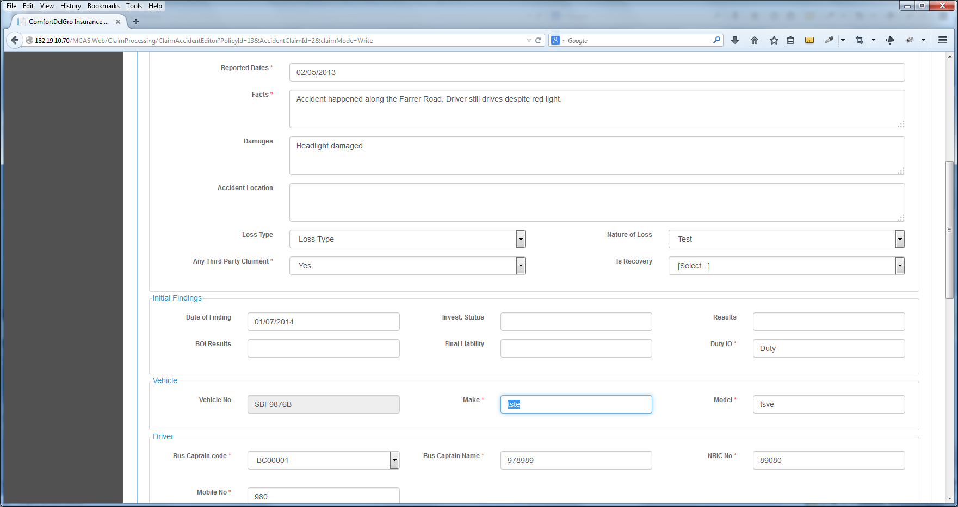

1. Change the Is Recovery Label to Recoverable
2. Vehicle Make and Vehicle Model are to match Vehicle No.

**Changes To The System Admin Tab**

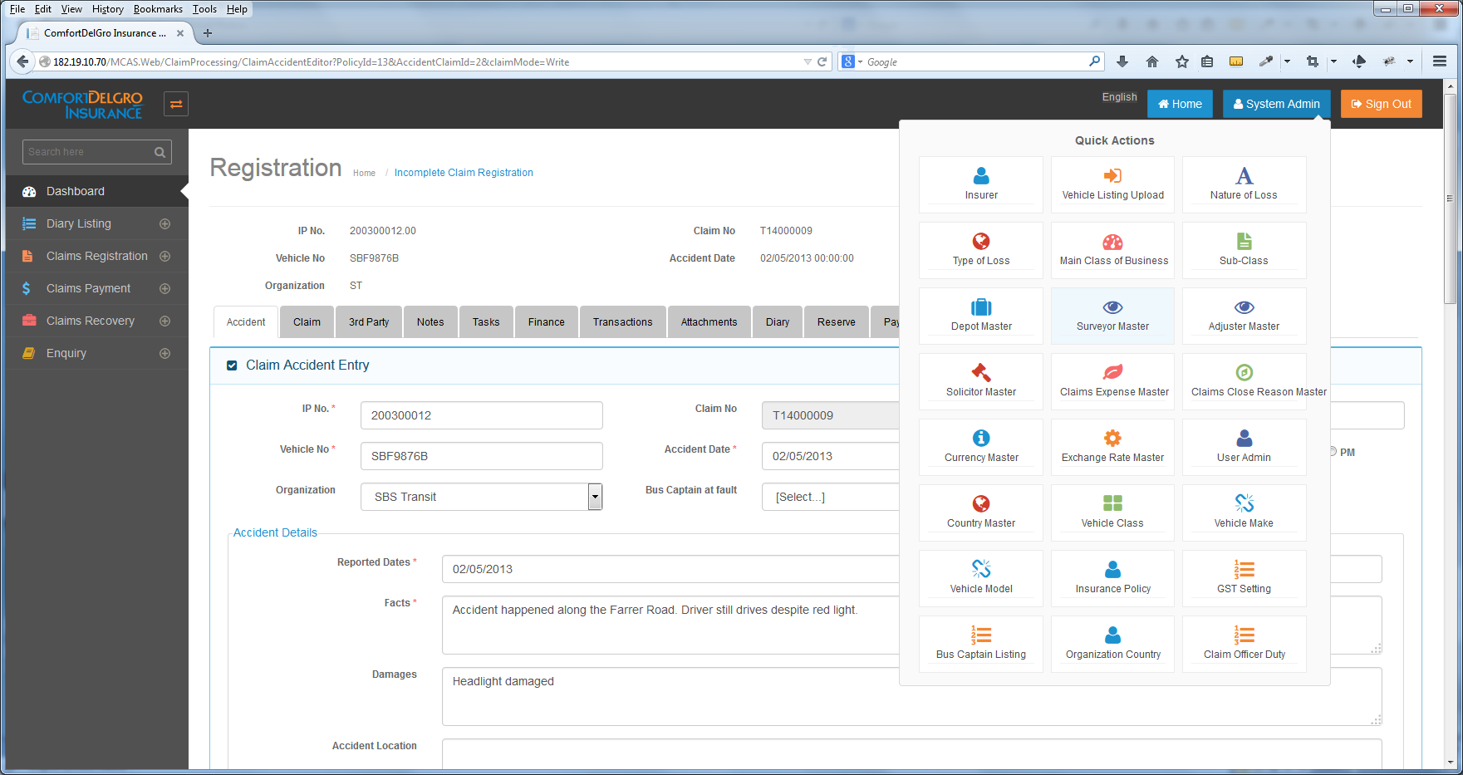

1. To include a Master Table and Tab for LOU Rate
2. LOU Rate has only two values 250 & 350. Allow Users to add more values and to edit current Values.
3. To include a Master Table and Tab for Hospitals
4. Hospital Fields to be provided by CDGI

**Add New Unreported Claims Section**

1. Add a new Section – Unreported Claims Registration under Claims Registration and below Incomplete Claims Registration
2. Allow All Fields to be input
3. Allow Users to save these input and System will generate a series of running Unreported Claims Number
4. To have the functions to close the Case as well as to convert the Claims to the New Claims Registration – These fields will be opened up after the existing Claims Module is up.

**Changes To The Diary Tab**

1. To Remove The Email Body Column
2. Change the Add New Parties Label to Add New Diary

**Changes To The Payment Tab**

1. To Grayed out the Payment Tab for all Sections except Claims Payment Module
2. To integrate Finance Tab to the Payment Tab
3. Include a Finance Breakdown Button next to the Cancel Button
4. When user clicks on it – the Finance Tab will appear
5. System will map the Local Currency Value and Payment Tab to one of the sections in the Finance Tab and System will need to balance out (make sure that all the breakdowns = Local Currency)
6. Finance Tab will be removed

**Changes To The Transaction Tab**

1. To change the Transaction Tab to Mandate
2. To change all Transaction Label to Mandate
3. CDGI will come back to us to implement a Process Flow whereby Authorized Users will come to this Tab to approve Mandate Entries

**Alert Indicator**

1. System to keep track of Accident Reserve and when Accident Reserve hits $15,000.10. System must alert Users about the claim.